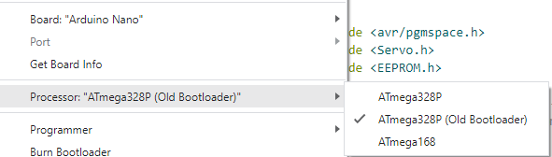

Nano

328P

Old Bootloader